
SRM Institute of Science and Technology
Mode of Exam
OFFLINE-SET C
College of Engineering and Technology
School of Computing
DEPARTMENT OF COMPUTING TECHNOLOGIES
SRM Nagar, Kattankulathur – 603203, Chengalpattu District, Tamilnadu
Academic Year: 2022-2023 (ODD/EVEN): ODD
Test: CLAT-1 Date: 08-09-2022
Course Code & Title: 18CSE356T - DOS Duration: 1 Hour
Year & Sem: III & V Max. Marks: 25

Course Articulation Matrix: (to be placed)
S.No. | Course Outcome | PO1 | PO2 | PO3 | PO4 | PO5 | PO6 | PO7 | PO8 | PO9 | PO10 | PO11 | PO12
1 | CO1 | 3 | 2 | 2 | 3 | 3 | 2 | - | - | 3 | 2 | - | 3

Part – A
( 15 x 1 = 15 Marks)
Instructions: Answer all
Q. No | Question | Marks | BL | CO | PO | PI Code
1 | Distributed system is a collection of independent computers that appears to its users as a _______.  - Multiple systems  - Multiple coherent system  - Single incoherent system  - Single coherent system | 1 | 1 | 1 | 1 | 1.6.1*
2 | One of the following is not an advantage of DS over isolated PC.  - Device Sharing  - Data Sharing  - Security  - Efficiency | 1 | 1 | 1 | 1 | 1.6.1*
3 | ______ not only increases availability, but also balances the load between components leading to better performance.  - Distribution  - Replication  - Duplication  - Migration | 1 | 2 | 1 | 1 | 1.6.1*
4. | Collection of similar workstations/PCs, closely connected by means of a high-speed LAN  - Grid Computing  - Cluster Computing  - Transaction Processing Systems  - Pervasive Computing | 1 | 2 | 1 | 1 | 1.6.1*
5. | ______ Property is either an entire transaction happens completely or not at all. If the transaction does happen, it happens as a single indivisible action.  - Consistent  - Isolation  - Atomic  - Durability | 1 | 1 | 1 | 1 | 1.6.1*
6. | Sequent, Encore are the examples for  - Switched Multiprocessor  - Switched Multicomputer  - Bus based Multiprocessor  - Bus based Multicomputer | 1 | 1 | 1 | 1 | 1.6.1*
7. | In ________ protocol before a processor writes data, other processor cache copies must be invalidated or updated.  - Snoopy cache  - Write through  - Write back  - Coherent Cache | 1 | 2 | 1 | 1 | 1.6.1*
8. | To connect n-CPUs and n-Memory modules, _________ cross point switches are required.  - n b.2(n-1) c. n² d. m*n | 1 | 3 | 1 | 1 | 1.6.1*
9. | Distributed operating systems consist of:  - Loosely coupled software on a loosely coupled hardware.  - Loosely coupled software on a tightly coupled hardware.  - Tightly coupled software on a loosely coupled hardware.  - Tightly coupled software on a tightly coupled hardware. | 1 | 2 | 1 | 1 | 1.6.1*
10. | An experimental file server is up 75% of the time and down for 25% of the time due to bugs. How many times does this file server have to be replicated to give an availability of at least 99 % ?  - 2 b.4 c. 8 d. 16 | 1 | 3 | 1 | 1 | 1.6.1*
11. | Loosely coupled OS allows users and machines to be fundamentally independent of one another and allows interaction wherever necessary.  - True b. False | 1 | 2 | 1 | 1 | 1.6.1*
12. | To simplify programming the high-level transaction fork off children that run in parallel with one another, on different machines, this concept is called ______________.  a. Nested Transaction  b. Complete Transaction  c. Partial Transaction  d. Transaction Monitor | 1 | 1 | 1 | 1 | 1.6.1*
13. | A multicomputer with 256 CPUs is organized as 16 × 16 grid. What is the worst case delay (in hops) that a message might have to take?  - 15 b. 10 c. 30 d. 32 | 1 | 3 | 1 | 1 | 1.6.1*
14. | Match the following  i. a- 2, b-3, c- 4, d-1  ii. a- 4, b-1, c- 2, d-3  iii. a- 1, b-4, c- 3, d-2  iv. a- 4, b-3, c- 1, d-2 | 1 | 2 | 1 | 4 | 1.6.1*
  - Location Transparency | - Solution to Coherence property
  - Microkernel | - Resources can free to move without changing their names
  - Multiprocessor | - services are kept in separate address space
  - Snoopy bus protocol | - Share a common memory
15. | In tightly coupled multiprocessor system, data rate is ______ loosely coupled multiprocessor system.  - higher than  - Lower than  - Same us  - almost similar to | 1 | 2 | 1 | 1 | 1.6.1*

Part – B
( 2 x 5 = 10 Marks)
Instructions: Answer all
1 | Brief about Network Operating System. Compare it with DOS.  Let us start with loosely-coupled software on loosely-coupled hardware, since this is probably the most common combination at many organizations. A typical example is a network of workstations connected by a LAN. In this model, each user has a workstation for his exclusive use. It may or may not have a hard disk. It definitely has its own operating system. All commands are normally run locally, right on the workstation.  However, it is sometimes possible for a user to log into another workstation remotely by using a command such as rlogin machine  The effect of this command is to turn the user's own workstation into a remote terminal logged into the remote machine. Commands typed on the keyboard are sent to the remote machine, and output from the remote machine is displayed on the screen. To switch to a different remote machine, it is necessary first to log out, then to use the rlogin command to connect to another machine. At any instant, only one machine can be used, and the selection of the machine is entirely manual.  Networks of workstations often also have a remote copy command to copy files from one machine to another. For example, a command like  rcp machine1:file1 machine2:file2 | 5 | 3 | 1 | 1 | 1.6.1*
2 | Discuss on Monolithic kernel and Micro kernel and give comparative analysis.  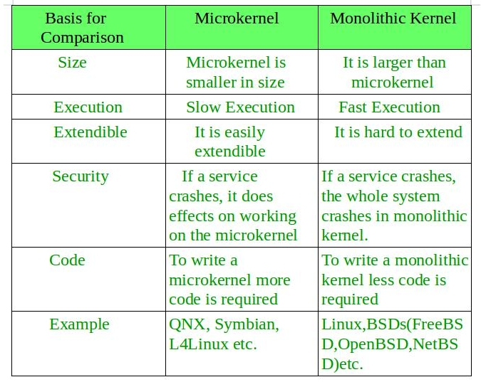 | 5 | 3 | 1 | 1 | 1.6.1*

*Performance Indicators are available separately for Computer Science and Engineering in AICTE examination reforms policy.

Course Outcome (CO) and Bloom’s level (BL) Coverage in Questions



Prepared By Approved by the Audit Professor/Course Coordinator

